Bridge Design Pattern

decouple an abstraction from its implementation so that the two can vary independently” is the intent for bridge design pattern as stated by GOF.
Bridge design pattern is a modified version of the notion of “prefer composition over inheritance”.

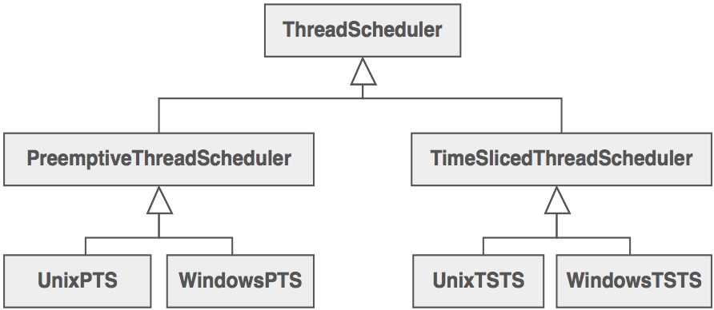

There are two types of thread schedulers, and two types of operating systems or "platforms". Given this approach to specialization, we have to define a class for each permutation of these two dimensions. If we add a new platform (say ... Java's Virtual Machine), what would our hierarchy look like?
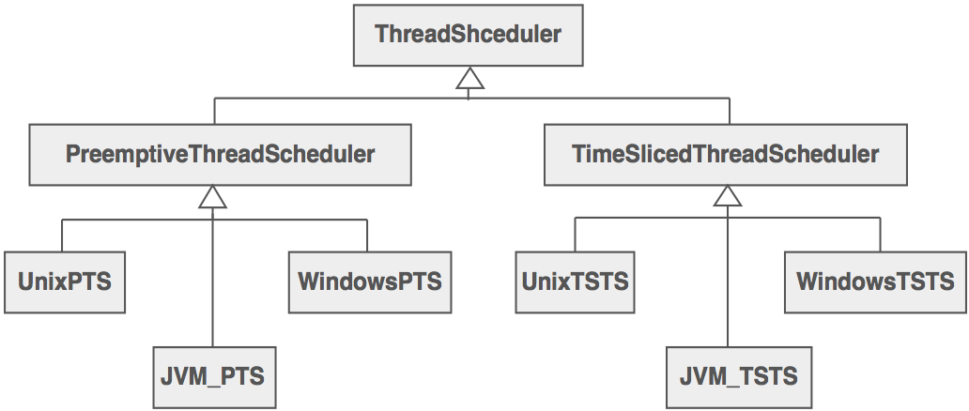

What if we had three kinds of thread schedulers, and four kinds of platforms? What if we had five kinds of thread schedulers, and ten kinds of platforms? The number of classes we would have to define is the product of the number of scheduling schemes and the number of platforms.
The Bridge design pattern proposes refactoring this exponentially explosive inheritance hierarchy into two orthogonal hierarchies – one for platform-independent abstractions, and the other for platform-dependent implementations.
Orthogonal:- If two base classes have no overlapping methods or data they are said to be independent of, or orthogonal to each other. Orthogonal in the sense means that two classes operate in different dimensions and do not interfere with each other in any way.
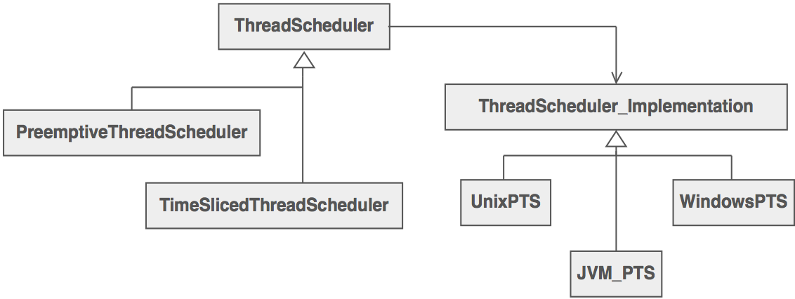

Discussion
Decompose the component's interface and implementation into orthogonal class hierarchies. The interface class contains a pointer to the abstract implementation class. This pointer is initialized with an instance of a concrete implementation class, but all subsequent interaction from the interface class to the implementation class is limited to the abstraction maintained in the implementation base class. The client interacts with the interface class, and it in turn "delegates" all requests to the implementation class.
The interface object is the "handle" known and used by the client; while the implementation object, or "body", is safely encapsulated to ensure that it may continue to evolve, or be entirely replaced (or shared at run-time).
Bridge is a synonym for the "handle/body" phrase. This is a design mechanism that encapsulates an implementation class inside of an interface class.
The implementation class is the body, and the interface class is the handle. The handle is viewed by the user as the actual class, but the work is done in the body. "The handle/body class phrase may be used to decompose a complex abstraction into smaller, more manageable classes.

Other example:
Before Bridge Design Pattern

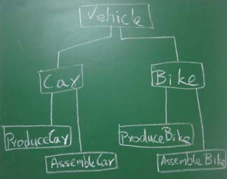

After Bridge Design Pattern
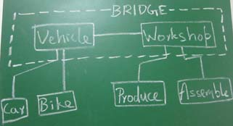

Participants
The classes and/or objects participating in this pattern are:
- Abstraction (BusinessObject)
  - defines the abstraction's interface.
  - maintains a reference to an object of type Implementor.
e.g. ThreadScheduler and Vehicle
these are also called as “handle”.
- RefinedAbstraction (CustomersBusinessObject)
  - extends the interface defined by Abstraction.
e.g. PreemptiveThreadScheduler,TimeSlicedThreadScheduler,Car and Bike.
- Implementor (DataObject)
  - defines the interface for implementation classes. This interface doesn't have to correspond exactly to Abstraction's interface; in fact the two interfaces can be quite different. Typically the Implementation interface provides only primitive operations, and Abstraction defines higher-level operations based on these primitives.
e.g. ThreadSchedulerImplementation ,WorkShop
these are also called as “body”.
- ConcreteImplementor (CustomersDataObject)
  - implements the Implementor interface and defines its concrete implementation.
e.g. Linux,Windows,Macintosh,Produce,Assemble.

In the first example Bridge from
ThreadScheduler (handle) to ThreadSchedulerImplementation (body)
In the second example Bridge from
Vehicle (handle) to WorkShop (body)

